**Title**: Developing a Photographic Essay – Making a Public Statement About a Social Problem or Issue

**Associated Files**: 2020 TRAILS Jenkins Photo Essay Directions

**Image Thumbnail**: none

**Abstract:**  After systematically reviewing common “sociological perspectives”, the sociological definition of a “social problem”, and being introduced to C.W. Mills’ “Sociological Imagination”, each student will develop a photographic essay of a social problem (a personal, reflective integrative and public statement about a social problem important to the student). Essay development enables students to demonstrate the intersection of personal problems and public structural contexts (C.W. Mills 1959 *Sociological Imagination*), then propose solutions to those problems. Using five to eight photographs the essay will reflect the social problem under consideration (first image), demonstrate the extent of the problem/issue (intermediary images), and provide a statement of individual and societal resolution (last two images). Photos must be presented and framed in such a way that they “read” like an essay. Sample distinguished projects are attached for viewing. Successful completion of the assignment enables students to use a sociological lens to demonstrate the relationship between personal problems and social issues (applying their sociological imaginations – C.W. Mills 1959).

**Resource Type**: Assignment

**Author 1**: Carol A. Jenkins – Glendale Community College – Arizona

**Subject Area:** Introduction to Sociology, Social Problems

**Class Level**: Any (undergraduate and/or graduate)

**Class Size:** Any

**Goal - 1:** to strengthen **theoretical grounding** for the understanding of “social problems”

Objective-1: to compare and contrast sociological approaches

Assessment-1: successfully complete selected objective questions for unit testing

**Goal-2:** to strengthen disciplinary specific knowledge -- **concept building**: “social problems”

Objective-2a: to define a “social problem” sociologically

Objective-2b: to compare and contrast the difference between a sociological perspective on social problems and one that emphasizes the individual experience.

Assessment-2a,b: successfully complete selected objective questions for unit testing

**Goal-3: to** strengthen **higher order reasoning and application skills**

Objective-3a: to develop an informed awareness about a social issue

Assessment-3a: individually complete an in-class inventory “*Causes That Are Important To You*”

Objective-3b: to analyze the *sociological imagination*

Assessment 3b: successfully complete reflection questions for unit testing

Objective-3c: to demonstrate application skills: create a photographic essay of a social problem

Assessment 3c: an assessment rubric developed to systematically evaluate the photo essays

**Key Words**: Social Problems – Sociological Imagination - Visual Sociology –Inequalities

**Language**: English

**Usage Notes**: Download complete exercise.

Time frame: In-class day-1 discuss comparative theoretical perspectives, what constitutes a “social problem”, complete inventory “Causes That Are Important to You”, introduce the sociological imagination. In-class day-2 display previous photo essays, review project assignment (syllabus), answer student questions, state due date (no late submissions). In-class day-3 (on the project due date) students display their essays, conduct an in-class gallery walk, and determine “People’s Choice Award” recipients. . In-class “days 1,2,3” are at the instructor’s discretion.

Photo essays are developed outside of the classroom. Recommendation: have students discuss the “topic” with the instructor. Example: “poverty” is too broad; encourage students to focus on a particular area of “poverty”. Internet image downloads are permitted but must not violate copyright laws.

Due date should appear in the syllabus course schedule and again on the directions page (about six weeks into the semester). Emphasize “no late submissions”. Unforeseen problems do happen: computer and printer glitches, personal issues, etc Ten days before the due date remind students there are “no late submissions” for whatever reason. Be ready to follow through with the expectation. Meeting deadlines is a valued work ethic and practice. The only exceptions I’ve granted: documented active duty military deployment, documented birth of a child, documented family death or funeral.

File: 2020 TRAILS Jenkins Photo Essay Directions

___________________________________________________________________________________________

**LECTURE: SOCIOLOGICAL PERSPECTIVES ON SOCIAL PROBLEMS**

**CONTEXTUAL LINKAGES: THEORETICAL GROUNDING**

**The sociological perspective focuses on the social rather than individual aspects of a problem** and asks why a condition like homelessness is repeated among large groups of people, and why some people are more at risk than others. Three major sociological perspectives – the functionalist, the conflict, and the interactionist – are powerful tools for understanding social problems. The following chart provides a brief review of the major perspectives.

__________________________________________________________________________________________________________________

**MAJOR PERSPECTIVES IN SOCIOLOGY**

PERSPECTIVE FOCUS INSIGHTS

**FUNCTIONALST** Social order or stability. Society consists of interdependent groups pursing common goals. Social order is maintained through social consensus, whereby people agree to cooperate in order to contribute to social order.

*Most likely to ask questions regarding the ways in which social institutions (family, education, religion, economics, government) help to maintain the social system; interprets each part of society in terms of how it contributes to the stability of the whole.*

**CONFLICT** Social conflict or change. Society is made up of conflicting groups, such as women and men, (including feminist each pursuing their own interests. Social order is maintained through

theories) . coercion, whereby social order is imposed by the powerful over the weak, such as how patriarchy is imposed by men on women.

*Most like to ask questions regarding whether certain social institutions benefit the “have” or the “have nots”; emphasizes the role of coercion and power in producing social order*.

**SYMBOLIC** Interaction between individuals Society is composed of individuals whose actions depend on **INTERACTION** interpreting each other’s behavior. Social order is maintained through constant negotiations between individuals trying to understand each other’s actions and reactions.

Most likely to ask questions regarding people’s everyday social interactions – how our definitions of ourselves and others underlie our behaviors.

___________________________________________________________________________________________________________________

While the media may make social problems seem like fads, which come and go, sociologists have long recognized that social problems seem to develop in a series of stages – problem definition, legitimacy, reemergence of demands, and rejection and institution building (Spector and Kitsuse).

Sociologists conduct several types of research on social problems, including demographic studies, survey research, field observation, and social experiments. Social policy is often formulated to address social problems in society and often reflect different ideological positions (conservatives – emphasize the moral dimension; liberals – emphasize social conditions).

**CONTEXTUAL LINKAGES: CONCEPT BUILDING**

**Sociologists who analyze social problems try to explain the following question: what is a social problem?** A social problem is distinguished from other social conditions by the fact that a significant number of people agree that it violates a social norm or value. Social problems such as crime, poverty, lack of medical care and drug abuse do not exist in isolation. These problems generate debate about causes and solutions; recognition that a problem exists does not guarantee consensus about a solution. Social problems exist when enough people in a society agree that a condition exists that threatens their quality of life and core values, and that something must be done to remedy the situation. Social problems create debate about the nature of the problem, its severity, and the best remedies. However, not all people count equally in defining social problems. those with more power have greater influence in defining social problems. The idea that society should intervene to remedy conditions that affect the lives of its citizens is a fairly recent innovation.

The following chart(s) enhance student understanding by “visualizing” the text narrative.

____________________________________________________________________________________________

**OPTION-1**  **SIX PERSPECTIVES ON SOCIAL PROBLEMS**

**VIEW OF SOCIETY ORIGINS**

**PERSPECTIVE and SOCIAL PROBLEMS OF SOCIAL PROBLEMS PROPOSED SOLUTIONS**

**SOCIAL** Views society as a vast organism “Sick” individuals or institutions fail Prevent the defects of “sick”

**PATHOLOGY** whose parts are inter-related; to keep pace with changing conditions individuals from being social problems are disruptions and disrupt the functioning of the transmitted to succeeding of this system. organism. generations; educate citizens

in “correct” beliefs and values

**SOCIAL** Views society as organized by a Social expectations (norms) fail, Isolate and correct the causes

**DISORGANIZA-** set of expectations or norms; creating normlessness, culture of disorganization.

**TION** social problems are symptoms conflict, and breakdown.

of the breakdown of those norms.

**VALUE** Defines social problems as Groups with different values and Conflicting groups engage

**CONFLICT** conditions that do not conform differing amounts of power meet in negotiations and reach

to society’s values. and compete. mutual accommodations.

**DEVIANT**  Defines social problems as The legitimate means of achieving “Re-socializing” deviants by

**BEHAVIOR** behaviors or conditions that cultural goals are blocked. increasing contacts with accepted

deviate from the norm. patterns of behavior makes the social system less rigid.

**LABELING** Holds that definitions of Society becomes aware that certain Change the definitions of what

deviance or social problems are behaviors or situations exist, and is considered deviant and take

subjective; separates deviant defines them as social problems. the profit out of the label.

and non-deviant people not by

what they do but by how society

reacts to what they do.

**INSTITUTIONAL** Holds that problems of social Social problems are a product of Engage in research and active

institutions produce patterns of the impersonal operation of social intervention.

deviance or that social institutions existing institutions both now and

must address these problems in the past.

through strategic social change.

Source: Based on Rubington / Weinberg 1971 Study of Social Problems. NY: Oxford and Janowitz 1978 The Last Half Century. Chicago: Univ of Chicago Press.

**_____________________________________________________________________________________________**

**_____________________________________________________________________________________________**

**OPTION-2 THE STUDY OF SOCIAL PROBLEMS: FIVE PERSPECTIVES**

|  |  |  |  |  |  |
| --- | --- | --- | --- | --- | --- |
| **PERSPECTIVE** | **DEFINITION** | **CAUSES** | **CONDITIONS** | **CONSEQUENCES** | **SOLUTIONS** |
|  |  |  |  |  |  |
| **SOCIAL PATHOLOGY** | Violation  of Moral Expectations | Failure or socialization. Can’t be taught; rejects values and beliefs. | Innate defects – immoral properties of individuals or societies. | Costly  Dehumanizing | Eugenics  Moralizing  individuals  Education |
| **SOCIAL DISORGANIZATION** | Failure in  expectations.  Normlessness  Culture conflict | Social Change  Disharmony | Anything technical, social, etc. that causes change. | Personal stress and  disorganization  System change or  failure | Equilibrate parts of the system (ex: slow down technology) |
| **VALUE CONFLICT** | Any conditions incompatible with prevailing values | Value conflict | Result of competition and contact between groups that have different values. | Costly.  Sacrifice of values. | Consensus  Trading  Power |
| **DEVIANT BEHAVIOR** | Departure from norms. | Learning and being committed to deviant ways. | Restricted  conventional  means.  Accessible deviant  means.  Restricted societal  ends. | Many possible consequences depending on the nature of the illegitimate world | Resocialization.  Increase legitimate means and ends. |
| **LABELING** | Conditions under which society defines social problems. | Awareness. | What labeler stands to gain. | Reordering  relations.  Secondary deviance. | Change definitions.  Take profit out of the labeling. |

Source: Rubington, Earl and Martin Weinberg, eds. 1971. The Study of Social Problems. Five Perspectives. New York: Oxford University Press.

**_____________________________________________________________________________________________**

**CONTEXTUAL LINKAGES: CRITICAL REASONING SKILL DEVELOPMENT**

*In the game of life we have a say in how to play our cards, but it is society that deals us the hand. The more we understand the game, the better players we will be.*

To begin the development of an informed concern about a contemporary social issue an in-class exercise is conducted (not graded). First, using a paper handout, each student prioritizes social problems and completes the valuing grid. In-class discussion follows comparing and contrasting divergent views and reasoning responses. Coming to a consensus is not necessary. This exercise sets the stage for understanding the “sociological imagination” and the development of the photographic essay.

____________________________________________________________________________________________________________________

**CAUSES THAT ARE IMPORTANT TO YOU**

Write the letter for each of the causes, in order of importance to you:

(2) Priority # 1_____ #2 _____ #3 _____ #4 _____ #5 _____ #6 _____ #7_____ #8 _____ #9 _____

|  |  |  |
| --- | --- | --- |
| A – improving the quality of  American education | D – issues of health care in the  United States | G – addressing issues of  Immigration in the USA |
| B – helping to solve the drug  problem | E – reducing racial/ethnic bias and  conflict | H - ______________________  ______________________ |
| C – reducing the problems of  poverty | F – solving the problem of global  warming | I - ______________________  ______________________ |

Thoughts: ___________________________________________________________________________________________________

___________________________________________________________________________________________________

**VALUES GRID**

You are not being called upon to defend the content of your beliefs at this point, but are asked

to evaluate how you arrived at your convictions and how firm you are with your beliefs.

______________________________________________________________________________________________________________

ISSUE RATIONALE Valuing Process *

1 2 3 4 5 6 7

_____________________________________________________________________________________________

(1) __________________________________________________________________________________________ 1 2 3 4 5 6 7

(2) __________________________________________________________________________________________ 1 2 3 4 5 6 7

(3) __________________________________________________________________________________________ 1 2 3 4 5 6 7

(4) __________________________________________________________________________________________ 1 2 3 4 5 6 7

Valuing Process: circle each number above to indicate the steps you have taken concerning each issue. These steps are necessary in order to develop stronger and clearer values.

1. Are you proud of (or do you prize or cherish) your position?
2. Have you publicly affirmed your position?
3. Have you chosen your position from alternatives?
4. Have you chosen your position after thoughtful consideration of the pros, cons, and conequances?
5. Have you chosen your position freely? (without pressure)?
6. Have you acted on or done anything about your beliefs?
7. Have you acted with repetition, pattern or consistency on this issue?

Please note that few of our beliefs or actions fit all seven of the valuing processes.

**_____________________________________________________________________________________________**

**PERSPECTIVE BUILDING: “THE SOCIOLOGICAL IMAGINATION”**

To transition to developing an understanding of the “sociological imagination” students are asked to read David Simon’s article “*Teaching the Sociological Imagination Paradigm*” which discusses the basic elements of Mills (1959) “sociological imagination”. Ask students to reflect on these three questions as they read Simon’s article.

*Q - How are personal troubles different from public issues?*

*Q - To what extent do you understand the basic definition of what social problems are and how they emerge?*

*Q - What would you say is “responsible” for most social problems, and why?*

_____________________________________________________________________________________________

Simon, David R. 2007. “Teaching the Sociological Imagination Paradigm” Teaching Matters. Vol 36. No 2. Fall. Washington, DC: American Sociological Association Section on Teaching and Learning in Sociology. _____________________________________________________________________________________________

C. Wright Mills (1956, 1961, 1963). The basic elements of the sociological imagination include the following concepts:

1. ***Personal troubles*** *– troubles* that “occur within the character of the individual and within the range of …

immediate relations with others; they have to do with (the) self and with those limited areas of social life of

which (one) is directly and personally aware: (Mills, 1959:8). Perceptions of and solutions to personal troubles

lie within one’s immediate environment, one’s family, workplace, school, religious organizations, or

neighborhoods. Thus if two college roommates quarrel and decide they no longer wish to room together, each

can resolve the problem by finding a more compatible partner, and most college campuses have a place to post

“seeking roommate” notices. Thus the problem is resolvable within the immediate environment of the college

campus. Social problems, on the other hand, are of a dramatically different nature.

2. ***Public issues***(social problems) – *issues* that transcend the local environment of work, family, and community.

Social problems involve a genuine crisis in institutional arrangements. Crises are genuine only when they

demand that choices be made about situations that confront a society. Troubles become issues when they become

widespread.

Consider unemployment. If, in a society of over 100 million workers, the only people who are unemployed are

those who refuse to work, that is a personal trouble. The cause is within the characters of individuals who are

either mentally incapacitated or morally wanting. If, however, that society suffers massive layoffs as businesses

“downsize” and move factories overseas in search of cheap labor and other financial advantages, sociological

forces are clearly at work. No amount of counseling or punishment of errant workers will resolve a crisis of

permanent recession.

Mills believed that many social problems indicate a “crisis in institutional arrangements” (Mills, 1959:9). Such

crises involve what sociologists term macro social problems.

Social problems are *objectively* harmful conditions. In other words, the harms involved can be measured or

counted as deaths or injuries, financial losses, and decline of trust in major institutions and the elites who head

them (Simon, 1995).

If harms are suffered at high rates with regularity by groups of people with certain characteristics and in specific

historical circumstances, they may be said to be socially patterned. If harms are socially patterned, they must, it

follows, be caused by social conditions. The recognition of such conditions is a key element of the sociological

imagination.

A basic assumption of the sociological imagination is that much human history is about the conflict between the

few who have control over scarce resources and the many who do not. These resources include *wealth*

(property), *income* (wages and salaries), *power* (the ability to make economic and political decisions that affect

the entire society), and *cultural values* (standards of right and wrong, beautiful and ugly).

3. ***Social Structure***: What is the particular structure of the entire society and what are its essential component

parts? How do the parts relate to one another? How does this society differ from others?

4. ***The Historical Era’s Main Drift*:** Where does the society stand in history? Is it on the ascent or decline? How

does social change happen? What are the essential features of the historical epoch? How is history made?

What master trends the current era does (main drift) will soon cause contractions and social problems?

5. ***Biography*** (social character). Mills believed it is important to answer the following questions about social

character: What kinds of men and women characterize the society? What kinds of “human nature” are evolving?

In what ways are social characteristics shaped? Which characteristics are encouraged, and which are repressed?

What types of “human nature” are revealed in the character we observe in society in this period? How is human

nature shaped by the society’s dominant institutions?

For Mills a **feature of social character** that must be addressed is ***alienation***. What are the institutional

conditions responsible for feelings of alienation and low self-esteem in individuals/ How are these alienating

conditions within institutions related to various social problems? What can be don’t to overcome alienating

conditions and the feelings they engender in individuals? Mills also believed that no sociological understanding

of social character is complete without an analysis of alienation (Mills, 1959:171). He believed that people are

confused about (mystified by) the causes of their alienation dur to the modern techniques of propaganda,

advertising, and manipulation.

Mills’ questions concerning structure, history, biography, and alienation provide a road map with which sociological inquiry can be undertaken.

_____________________________________________________________________________________________

**ASSESSMENT: SAMPLE EMBEDDED TEST QUESTIONS ---THEORETICAL GROUNDING, CONCEPT BUILDING –“SOCIAL PROBLEM”, the SOCIOLOGICAL IMAGINATION**

1. The **“sociological perspective”**
2. Demonstrates how broader societal factors influence our personal lives
3. Provides greater understanding of the complex relationship between individual experience and one’s

social location

C Provides a point of view for the study of specific problems

D. **all of these**

1. Which of the following is NOT a characteristic of a good sociological question?
2. The question asks why a condition exists.
3. The question asks about the social rather than the individual aspects of a problem.
4. The question asks how a condition is distributed in a society
5. **The question asks what action is necessary to eliminate a condition that is unrelated to policy questions.**
6. The question asks whether a condition affects some people more than others.
7. Match the following concerning **major theoretical perspectives in American Sociology**:

B **symbolic interactionists** A. assume society is a complex system whose parts work together to promote solidarity

and stability; most likely to ask questions regarding the ways in which social

A **structural** **functionalists**  institutions help to maintain the social system. Focus: how society is held together.

C **conflict theorists**

B. analyze everyday social interactions of people – how definitions of ourselves and

others underlie our behaviors; it is not so much what people do that matters as much

as what meaning they attach to their behavior. Focus: how people experience society

C. see society as an arena of inequality that generates conflict and change; focuses on

whether certain social institutions benefit the “haves” or the “have nots”; emphasizes

the role of coercion and power in producing social order. Focus: how society is divided.

1. **Sociologists regard social problems** as
2. Conditions that seldom produce disagreement
3. **A situation that exists when enough people define a situation as threatening their quality of life and to cherished values**
4. A matter of individual responsibility
5. Existing only when social scientists have determined there is measurable empirical evidence that significant harm has been

done to a society.

5. C. Wright Mills’ **sociological imagination** (perspective) stresses that

A. common sense is a good predictor of human behavior

B. personality is the major factor underlying behavior

C.  **to understand a given individual’s or group’s experiences, one has to have knowledge of the social, cultural and**

**historical context in which people live**

____________________________________________________________________________________________

**APPLICATION – THE SOCIOLOGICAL IMAGINATION**:

Introduction: Using scheduled instructional time, samples of previous student essays are displayed around the classroom, project instructions found in the syllabus are reviewed, and questions students may have about their assignment are answered. **Unframed sample distinguished projects are attached.**

Assignment: **Each student will develop a photographic** essay of a social problem (a personal, reflective integrative and public statement about a social problem important to the student). Using five to eight photographs the essay will reflect the social problem under consideration (first image), demonstrate the extent of the problem/issue (intermediary images), and provide a statement of individual and societal resolution (last two images). Essay development enables students to demonstrate the intersection of personal problems and public structural contexts (C.W. Mills 1959 *Sociological Imagination*), then propose solutions to those problems. Photos must be presented and framed in such a way that they “read” like an essay.

Photo essays are developed outside of the classroom. Recommendation: have students discuss the “topic” with the instructor. Ex: “poverty” is too broad; encourage student to focus on a particular area of “poverty”. Internet image downloads are permitted but must not violate copyright laws.

In addition to developing the photographic essay, students will also complete **graded reflection questions** to be attached to the back of the framed essay.

*Q-1 How and to what extent did completing the photo essay enable you to provide a personal, reflective*

*and integrative statement about a social problem that is important to you (include rationale)?*

*Q-2 How and to what extent did the development of the photo essay enable to you use a sociological*

*perspective to transform a personal problem into a public social issue needing resolution (include rationale)?*

*Q-3 How and to what extent would you recommend the photo essay remain a required course project for next*

*semester’s Introduction and/or Social Problems classes and why?*

On the assignment due date, **students will position their essays around the classroom.** Although the instructor’s task is to systematically evaluate each student’s visual presentation (photo essay), in many venues the quality of visual presentations are “juried” or evaluated by professionals in the field. Students will serve as professionals and “jury” their peer’s projects. There will be a “gallery walk” in class, and a juror determined “People’s Choice Award” for “distinguished” essays.

If instructional time is not problematic students can learn how to systematically “jury” peer presentations by using the comparative chart below to evaluate, rank and identify winners of the “**People’s Choice Awards**. To be fair, jurors need to be looking for the same items in each presentation. The class must reach consensus. Try to avoid students recommending their “friends” rather than the most deserving essays.

I have found it efficacious to forego the systematic peer evaluations in favor of asking students to collectively identify and rank essays as #1, #2, #3 in favor of tallying of a count with the raising of hands. In the case of ties, two certificates may be awarded.

Winners are recognized by receiving a “People’s Choice Award” Certificate signed by the Department Chairperson and the Instructor of Record. **Award certificates** are given to student’s essays ranking 1, 2, and 3. Certificates are generated by the instructor.

Students are encouraged to keep their photo essay, instructions and grading rubric for inclusion in their “transfer” portfolios. Being able to demonstrate critical reasoning skills through a non-written medium is valued by many university departments.

_____________________________________________________________________________________________

**IN-CLASS GALLERY WALK ASSESSMENT RUBRIC ……** **PEER REVIEW**

In many venues the quality of visual presentations are “juried” or evaluated by professionals in the field. The assessment criteria is presented below. To be fair, jurors need to be looking for the same items in each presentation. The numbers preceding each criteria represent “the extent to which” the item has been accomplished. The appropriate number will be inserted in the appropriate column.

_____________________________________________________________________________________________

**Student Essay #**

|  |  |  |  |  |  |  |  |  |  |  |  |  |  |  |  |  |  |  |  |  |  |  |
| --- | --- | --- | --- | --- | --- | --- | --- | --- | --- | --- | --- | --- | --- | --- | --- | --- | --- | --- | --- | --- | --- | --- |
| ASSESSMENT QUESTION | POINT  VALUE |  | 1 | 2 | 3 | 4 | 5 | 6 | 7 | 8 | 9 | 10 | 11 | 12 | 13 | 14 | 15 | 16 | 17 | 18 | 19 | 20 |
|  |  |  |  |  |  |  |  |  |  |  |  |  |  |  |  |  |  |  |  |  |  |  |
| TITLE | 10-8-6-4 2-0 |  |  |  |  |  |  |  |  |  |  |  |  |  |  |  |  |  |  |  |  |  |
| PHOTOS REFLECT SOCIAL PROBLEM | 10-8-6-4-2-0 |  |  |  |  |  |  |  |  |  |  |  |  |  |  |  |  |  |  |  |  |  |
| PHOTOS DEMON-STRATE A GIVEN POSITION ON THE ISSUE | 10-8-6-4-2-0 |  |  |  |  |  |  |  |  |  |  |  |  |  |  |  |  |  |  |  |  |  |
| PHOTOS ELICIT AN EMOTIVE RESPONSE FROM THE VIEWER | 10-8-6-4-2-0 |  |  |  |  |  |  |  |  |  |  |  |  |  |  |  |  |  |  |  |  |  |
| PRESENTATION “READS” LIKE AN ESSAY | 10-8-6-4-2-0 |  |  |  |  |  |  |  |  |  |  |  |  |  |  |  |  |  |  |  |  |  |
| USED FIVE TO EIGHT PHOTOS | 10-8-6-4-2-0 |  |  |  |  |  |  |  |  |  |  |  |  |  |  |  |  |  |  |  |  |  |
| PRESENTATION (MOUNTING) OF PHOTOS | 10-8-6-4-2-0 |  |  |  |  |  |  |  |  |  |  |  |  |  |  |  |  |  |  |  |  |  |
| CITED LOCATION WHERE PICTURES WERE TAKEN – OR – CITED WHERE GRAPHICS WERE FOUND | 10-8-6-4-2-0 |  |  |  |  |  |  |  |  |  |  |  |  |  |  |  |  |  |  |  |  |  |
| TOTAL SCORE | (___ of 200) |  |  |  |  |  |  |  |  |  |  |  |  |  |  |  |  |  |  |  |  |  |

PHOTO ESSAY RANKED #1 _________ #2 __________ #3 _________

COMMENTS/OBSERVATIONS: PEER JUROR (print name): ___________________________

_______ ____ _______________________________________________________ ____

**PEOPLE’S CHOICE AWARD CERTIFICATE SAMPLE**

(adjust for first, second, third place; using different colors for each)



**DEPARTMENT OF SOCIAL SCIENCES - SOCIOLOGY**

Date: ___________

ACKNOWLEDGES

__________________________________

as the

VISUAL SOCIOLOGY STUDENT COMPETITION

***“PEOPLE’S CHOICE” FIRST PLACE WINNER***

PHOTOGRAPHIC ESSAY OF A SOCIAL PROBLEM IMPORTANT TO THE STUDENT

CHOSEN BY STUDENTS ENROLLED IN (Semester) (Year) SOC 101: INTRODUCTION TO SOCIOLOGY

Signature: _______________________________ Signature: ___________________________________

Print Name: _______________________________ Print Name: Carol A. Jenkins, PhD Instructor of Record

Dept Social Sciences - Chairperson Dept Social Sciences – Chairperson for Sociology ______________________ _________________________________________ _______

**Although some colleagues prefer formal student presentations, I do not.** Doing so negatively impacts instructional time (35 students in each class). The images must tell the story without a narrative. However, there are always essays students want to learn more about from the author. About 30 minutes are set aside for volunteers to present and answer questions concerning their essays. Including this opportunity is crucial. Many of these essays are reflections of the connection between student personal issues and the context in which those problems find themselves.

My preference: Insert the complete assignment directions and grading expectations and rubric into the course syllabus (sample syllabus inclusion attached). Doing so establishes the project standards, expectations, assessment criteria, due dates and in-class project peer review, analysis, reflection and assessment activities.

**ASSESSMENT:** **PHOTOGRAPHIC ESSAYS**

The Professor will use a grading rubric which is identical to the essay directions rubric found in the syllabus and an additional assessment rubric for the reflection questions. When completed both are returned to the student.

Grading essays is very labor intensive and time consuming. Using the assessment rubric is essential. Be ready to get assistance carrying the essays back to your office, then again when returning the graded essays to the classroom. Essays should be graded and returned in a reasonable time (two weeks max). The instructor determines which essays will be publicly displayed. With student written permission, “Distinguished Essays” are displayed on campus.

______________________________ __ ________

**INSTRUCTOR’S ASSESSMENT RUBRIC: PHOTOGRAPHIC ESSAY**

*(****to be attached to the essay and returned to the student***)

In many venues the quality of visual presentations are “juried” or evaluated by professionals in the field. Your instructor’s task is to systematically evaluate your visual presentation (photo essay). The assessment criteria are presented below. To be fair, jurors need to be looking for the same items in each presentation. The numbers preceding each criterion represent “the extent to which” the item has been accomplished. The appropriate number will be circled. This will become the instructor’s evaluation of your work.

Social Problem under consideration: _________________________________________________

Student Name: ______________________________________________ Class: ______________

10 08 06 04 02 00 Title: ___________________________________ ( ) appropriate ( ) inappropriate

20 16 12 08 04 00 Photographs reflect the social problem under consideration.

10 08 06 04 02 00 Photographs illicit an emotive response from the viewer.

10 08 06 04 02 00 Presentation “reads” like an essay, as instructed.

10 08 06 04 02 00 Photographs demonstrate your position on the issue

10 08 06 04 02 00 Photograph demonstrates a societal recommendation to resolve the issue.

10 08 06 04 02 00 Used eight photographs as instructed.

10 08 06 04 02 00 Presentation (ex: mounting) of photographs ( ) creative ( ) purposeful

10 08 06 04 02 00 ( ) Cited location where picture(s) were taken.

( ) Cited graphic source (circle) using MLA-APA-ASA-Chicago format

( ) Received written informed consent if taking pictures of real people.

Total Points Earned = _________ of 100 Evaluator: ____________________________________ Date: _________

__________________________ _________________ ___________

__________________________ _

**ASSESSMENT: REFLECTIONS QUESTIONS**

**SCORES ARE DEPENDENT UPON THE QUALITY OF ANSWERS**

(90-100% excellent 80-89% good 70-70% fair 60-69% marginal 0-59% unacceptable)

Q-1 How and to what extent did completing the photo essay enable you to provide a personal, reflective

and integrative statement about a social problem that is important to you (include rationale)?

Q-2 How and to what extent did the development of the photo essay enable to you use a sociological

perspective to transform a personal problem into a public social issue needing resolution

(include rationale)?

Q-3 Would you recommend the photo essay remain a required course project for next semester’s

Introduction and/or Social Problems classes? Why or why not?

____________________________________________________________________________________________________________________

**REFLECTION QUESTIONS 1,2,3 Focus: quality of responses**

**ASSESSMENT RANGE OF SCORES:**  EXCELLENT VERY GOOD SATISFACTORY BASIC UNACCEPTABLE

90-100% 80-89% 70-79% 60-69% 0-59%

Question – 1,2,3 20 points possible each (18-20) (16-17) (14-15) (12-13) (0-11)

**UNDERSTANDING OF THE TOPIC**: 5 4 3 2 1

Effectively uses examples and insights

from the in-class exercise.

**LEVEL OF CONTENT:** 5 4 3 2 1

Content indicates synthesis of ideas,

concepts, theories in support of answer.

**QUALITY OF ANALYSIS:** 5 4 3 2 1

Main points are well developed with high

quality and quantity (evidence) of support.

**CONCLUSIONS:** 5 4 3 2 1

Original thought, interpretation, application

reveals high degree of critical thinking.

**REFLECTION QUESTION TOTAL SCORE**: _____ of 20

**CONCLUSIONS:**

Successful completion of the photographic essay continually enables students to *use the sociological perspective to transform personal problems into social issues and propose solutions to those problems* (C.W.Mills 1959).

Sample student response to the question “***Was the assignment worth it****”?* *“This assignment was more difficult than I thought it would be. I had to think about a social problem that bothered me, analyze it, figure out a solution, find just the right images, and then frame the pictures in a readable way. Thank you. I’ll never forget this experience!”*

The following is a **sample assignment direction sheet** for inclusion in the course syllabus followed by **sample photographic essays.**

**SYLLABUS DIRECTIONS: PHOTOGRAPHIC ESSAY OF A SOCIAL PROBLEM OF INTEREST TO THE STUDENT**

Course: Soc 101 Introduction to Sociology and Soc 251 Social Problems Professor: Carol A. Jenkins, PhD – Sociology

Course competency to be mastered: ….the application of the “*sociological imagination*” to everyday life (real life issues)

Learning Goal/Outcome: …

* Your instructor will show examples of students’ previous work in class.
* Each student will be responsible for developing a photographic essay of a social problem.
* A photographic essay is a personal, reflective and integrative statement about a social problem important to the student.
* The five to eight photographs should

- Reflect the social problem under consideration (first image)

- Present an overview of the issue (intermediary images)

Directions: - Provide a statement of resolution for the issue (last image)

* Title your essay, but no written copy is to accompany the photographs. Place on back of essay – let pictures speak for themselves.
* Place the photos in such an order of presentation that they “read” like an essay.
* Photographs downloaded from the Internet are acceptable as long as copyright laws are not violated.
* Citations are required for each image. Use correct citation formatting of your academic major (ASA, MLA, APA, Chicago).
* Photographs you have taken - a citation listing is required (location, date, and a signed informed consent if using people images).
* Please avoid large poster board presentations. The use of actual frames is expected (first impressions are important).
* The due date is listed in the syllabus course schedule (day, month, class hour - beginning of class). No late submissions.
* Be sure to print your complete name, class days and class hour on the back of your project.
* Securely tape citation list on back of project.
* Please print your name on the back of the frame (in case the documentation page gets separated from the frame).

**No late work will be accepted on this assignment**. Meeting deadlines and following directions are valued work skills.

If downloading from the internet here’s a sample ASA (Sociology) citation format:

Eisenstein, Paul A. “*Indiana Stakes Claim to Electric Car Industry*”. Retrieved November 1, 2011.

http://www.newsvine.com/_news/2010/03/11/4005628-indiana-stakes-claim-to-electric-car (if available, give image number jpg-____)

Assessment: Photographic Essay – Integrative Statement:

In many venues the quality of visual presentations are “juried” or evaluated by professionals in the field. Your instructor’s task is to systematically evaluate your visual presentation (photo essay). The assessment criteria is presented below. To be fair, jurors need to be looking for the same items in each presentation. The numbers preceding each criterion represent “the extent to which” the item has been accomplished. The appropriate number will be circled. “Total Points Earned” will become the instructor’s evaluation of your work.

Social Problem under consideration: ___________________________________ Student Name: ________________________________

10 08 06 04 02 00 Title: _____________________________________ ( ) appropriate ( ) inappropriate (topic and title are different)

20 16 12 08 04 00 Photographs reflect the social problem under consideration.

20 16 12 08 04 00 Photographs demonstrate a given position on the issue and recommendation to resolve issue.

10 08 06 04 02 00 Photographs illicit an emotive response from the viewer.

10 08 06 04 02 00 Presentation “reads” like an essay, as instructed.

10 08 06 04 02 00 Used five to eight photographs as instructed.

10 08 06 04 02 00 Presentation (ex: mounting) of photographs ( ) creative ( ) purposeful

10 08 06 04 02 00 ( ) Cited location where picture(s) were taken. OR ( ) Cited source of graphic (circle) MLA-APA-ASA or Chicago style

( ) Received written informed consent if taking pictures of real people.

Total Points Earned = _________ of 100 Evaluator: ___________________________

Reflection and analysis:

* Projects are placed around the classroom for everyone to see. Students then do a “gallery walk” to view the projects.
* Using the stated criteria, students “take on the role” of “jurist” to identify three “distinguished” essays to receive the

“People’s Choice Award” - signed certificates to include in their university transfer portfolios.

* Winners are asked to reflect on “*why did you choose this topic*”, “*what do you want others to understand about this topic*”, and

“*what can others do to resolve this problem”?*

* The instructor will acknowledge a “Best of Show” essay with a separate certificate.
* When possible distinguished essays from all classes are displayed on campus.

_____________________________________________________________________________________

**This exercise has been developed by** Dr. Carol A. Jenkins Glendale Community College – Arizona Please list citation on your assignment page

___________________________________________________________________________________

**PHOTOGRAPHIC ESSAYS ……. STUDENT PROJECTS**

INSTRUCTOR: DR. CAROL A. JENKINS Soc 101 Introduction to Sociology

Glendale Community College – Arizona

_____________________________________________________________________________________

**“COMMON THREADS TO OBESITY”**

**Essay by Student #1**

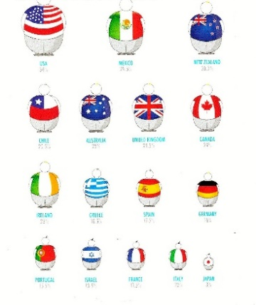 

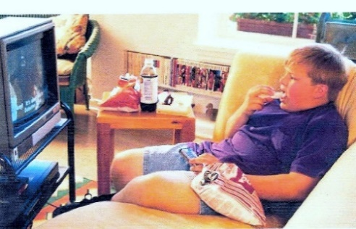  

 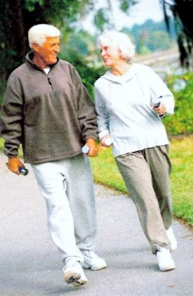 

_____________________________________________________________________________________

_____________________________________________________________________________________

**“MAY I HAVE A DRINK?”**

**Essay by Student #2**

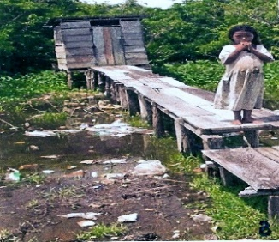 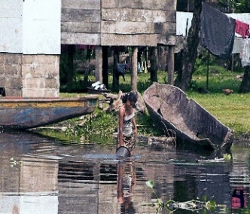 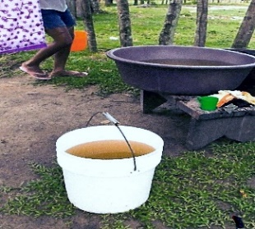 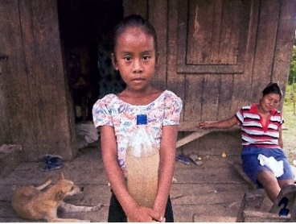

 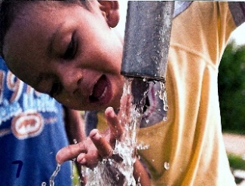  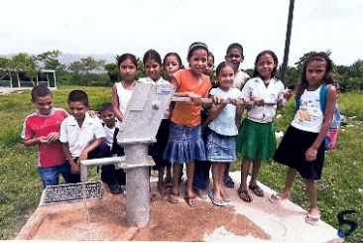

____________________________________________________________________________________

**“THIS IS MY HOME – WHERE’S YOURS?”**

**Essay by Student #3**

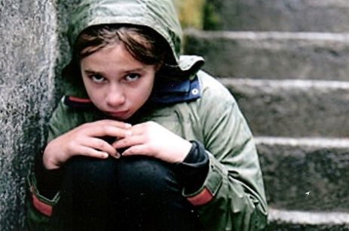 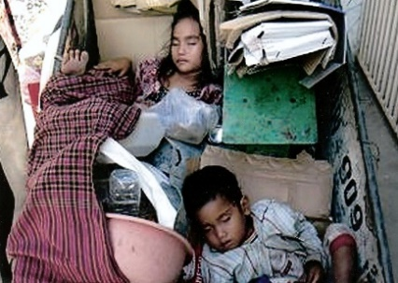 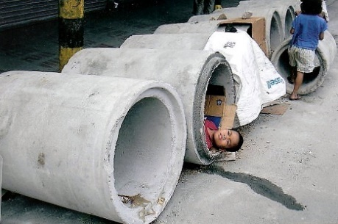

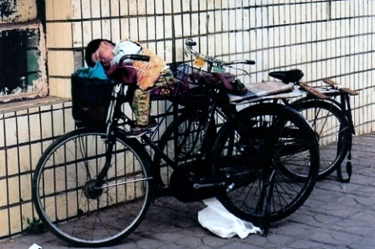 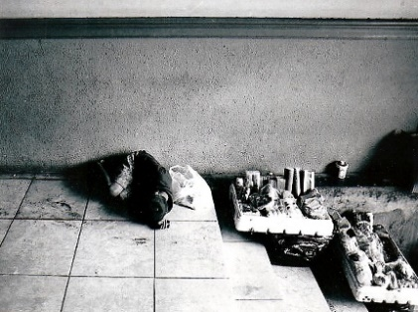 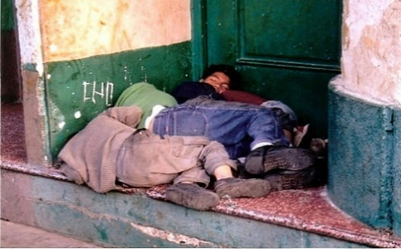

_____________________________________________________________________________________

_____________________________________________________________________________________

**“NOW WHAT?”**

**Essay by Student #4**

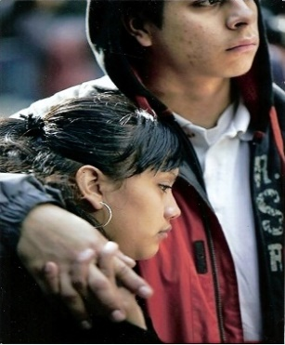 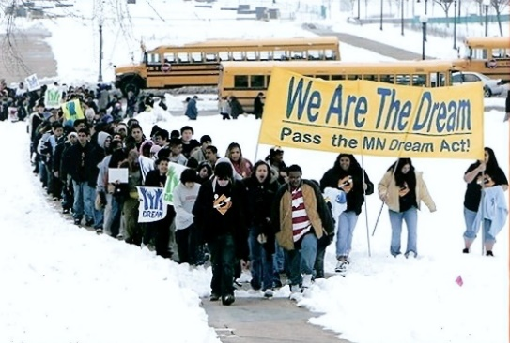 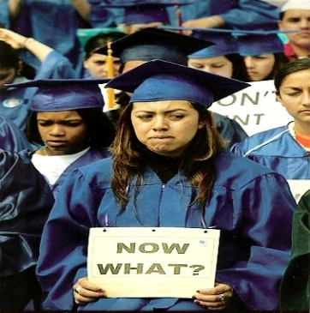

 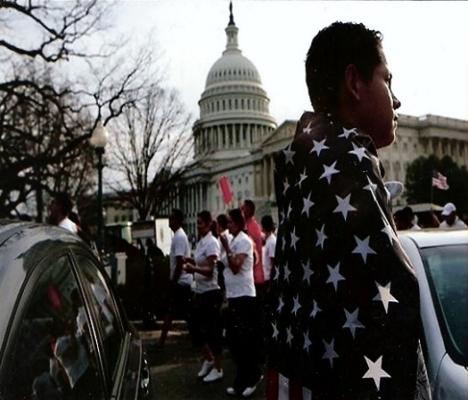 

_____________________________________________________________________________________

**“LESSONS IN INEQUALITY”**

**Essay by Student #5**

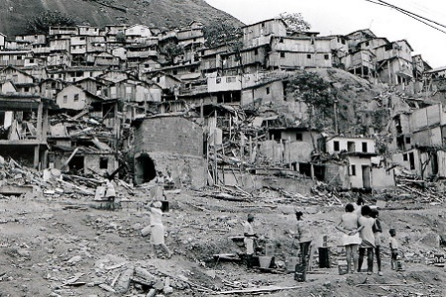 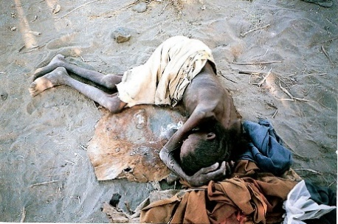 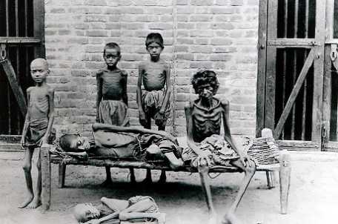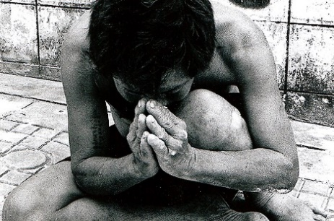 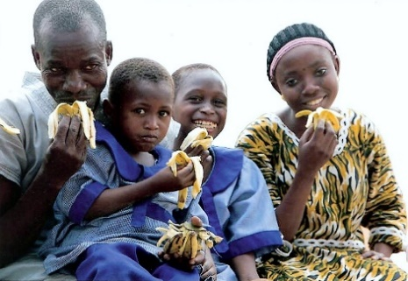 ______________________________________________________________________________________

___________________________________________________________________________________

**THE PAIN OF INSTANT GRATIFICATION**

**Essay by Student #6**

   

 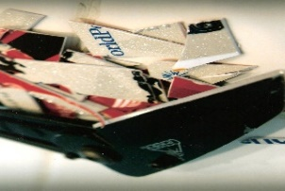  

_____________________________________________________________________________________

**REAL MEN PROTECT THEIR WOMEN**

**Essay by Student #7**

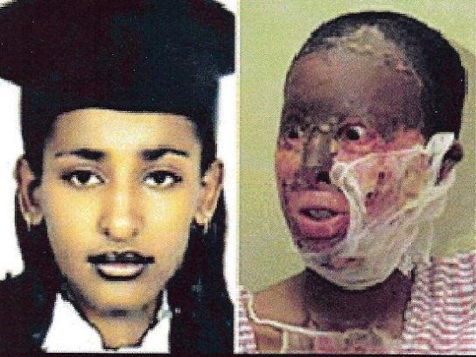 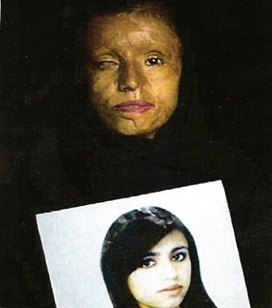 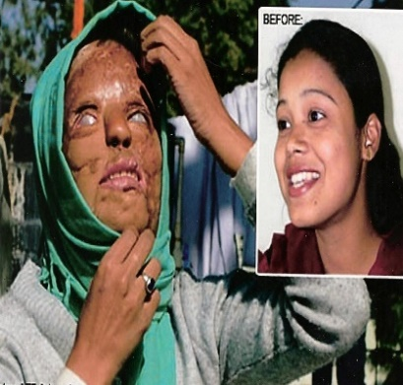

 

_____________________________________________________________________________________

_____________________________________________________________________________________

**“DEAR DICTATOR CHARLES TAYLOR: ENOUGH IS ENOUGH –**

**WE WANT A FREE AND DEMOCRATIC LIBERIA”**

**Essay by Student #7**

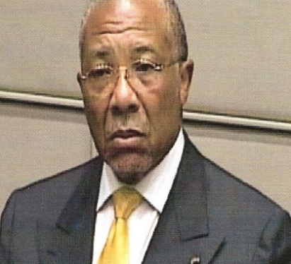 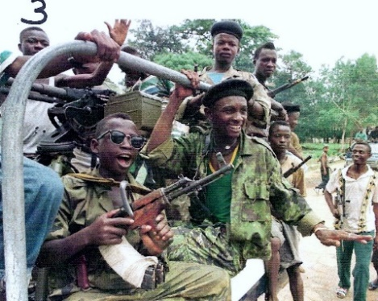 

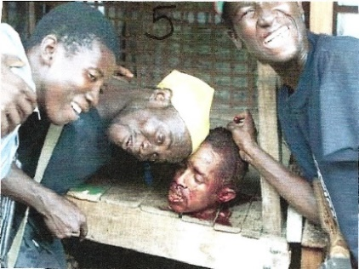 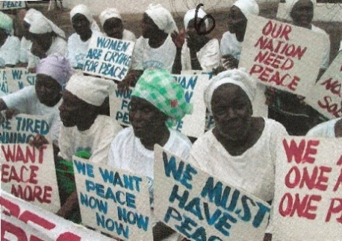 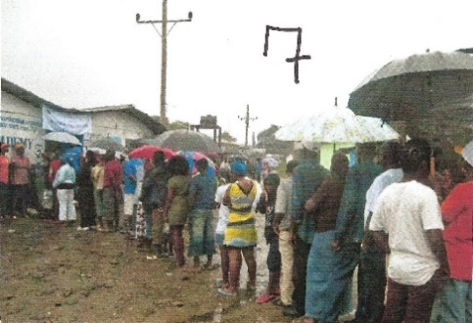

_____________________________________________________________________________________

**NOT FOR SALE**

**Essay by Student #9**

 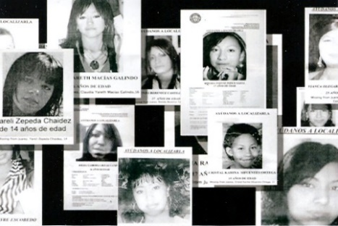 

 

_____________________________________________________________________________________

_____________________________________________________________________________________

**FALSE PROPHETS: PROSPERITY THEOLOGY**

**Essay by Student #10**

 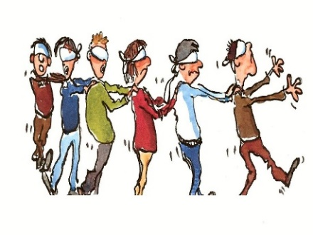 

 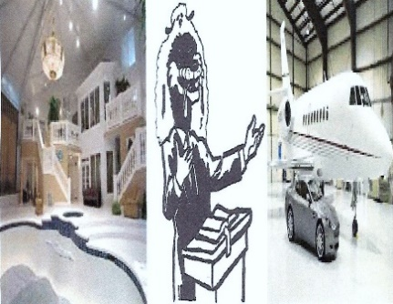 

_____________________________________________________________________________________

**SMALL WORK**

**Essay by Student #11**

   